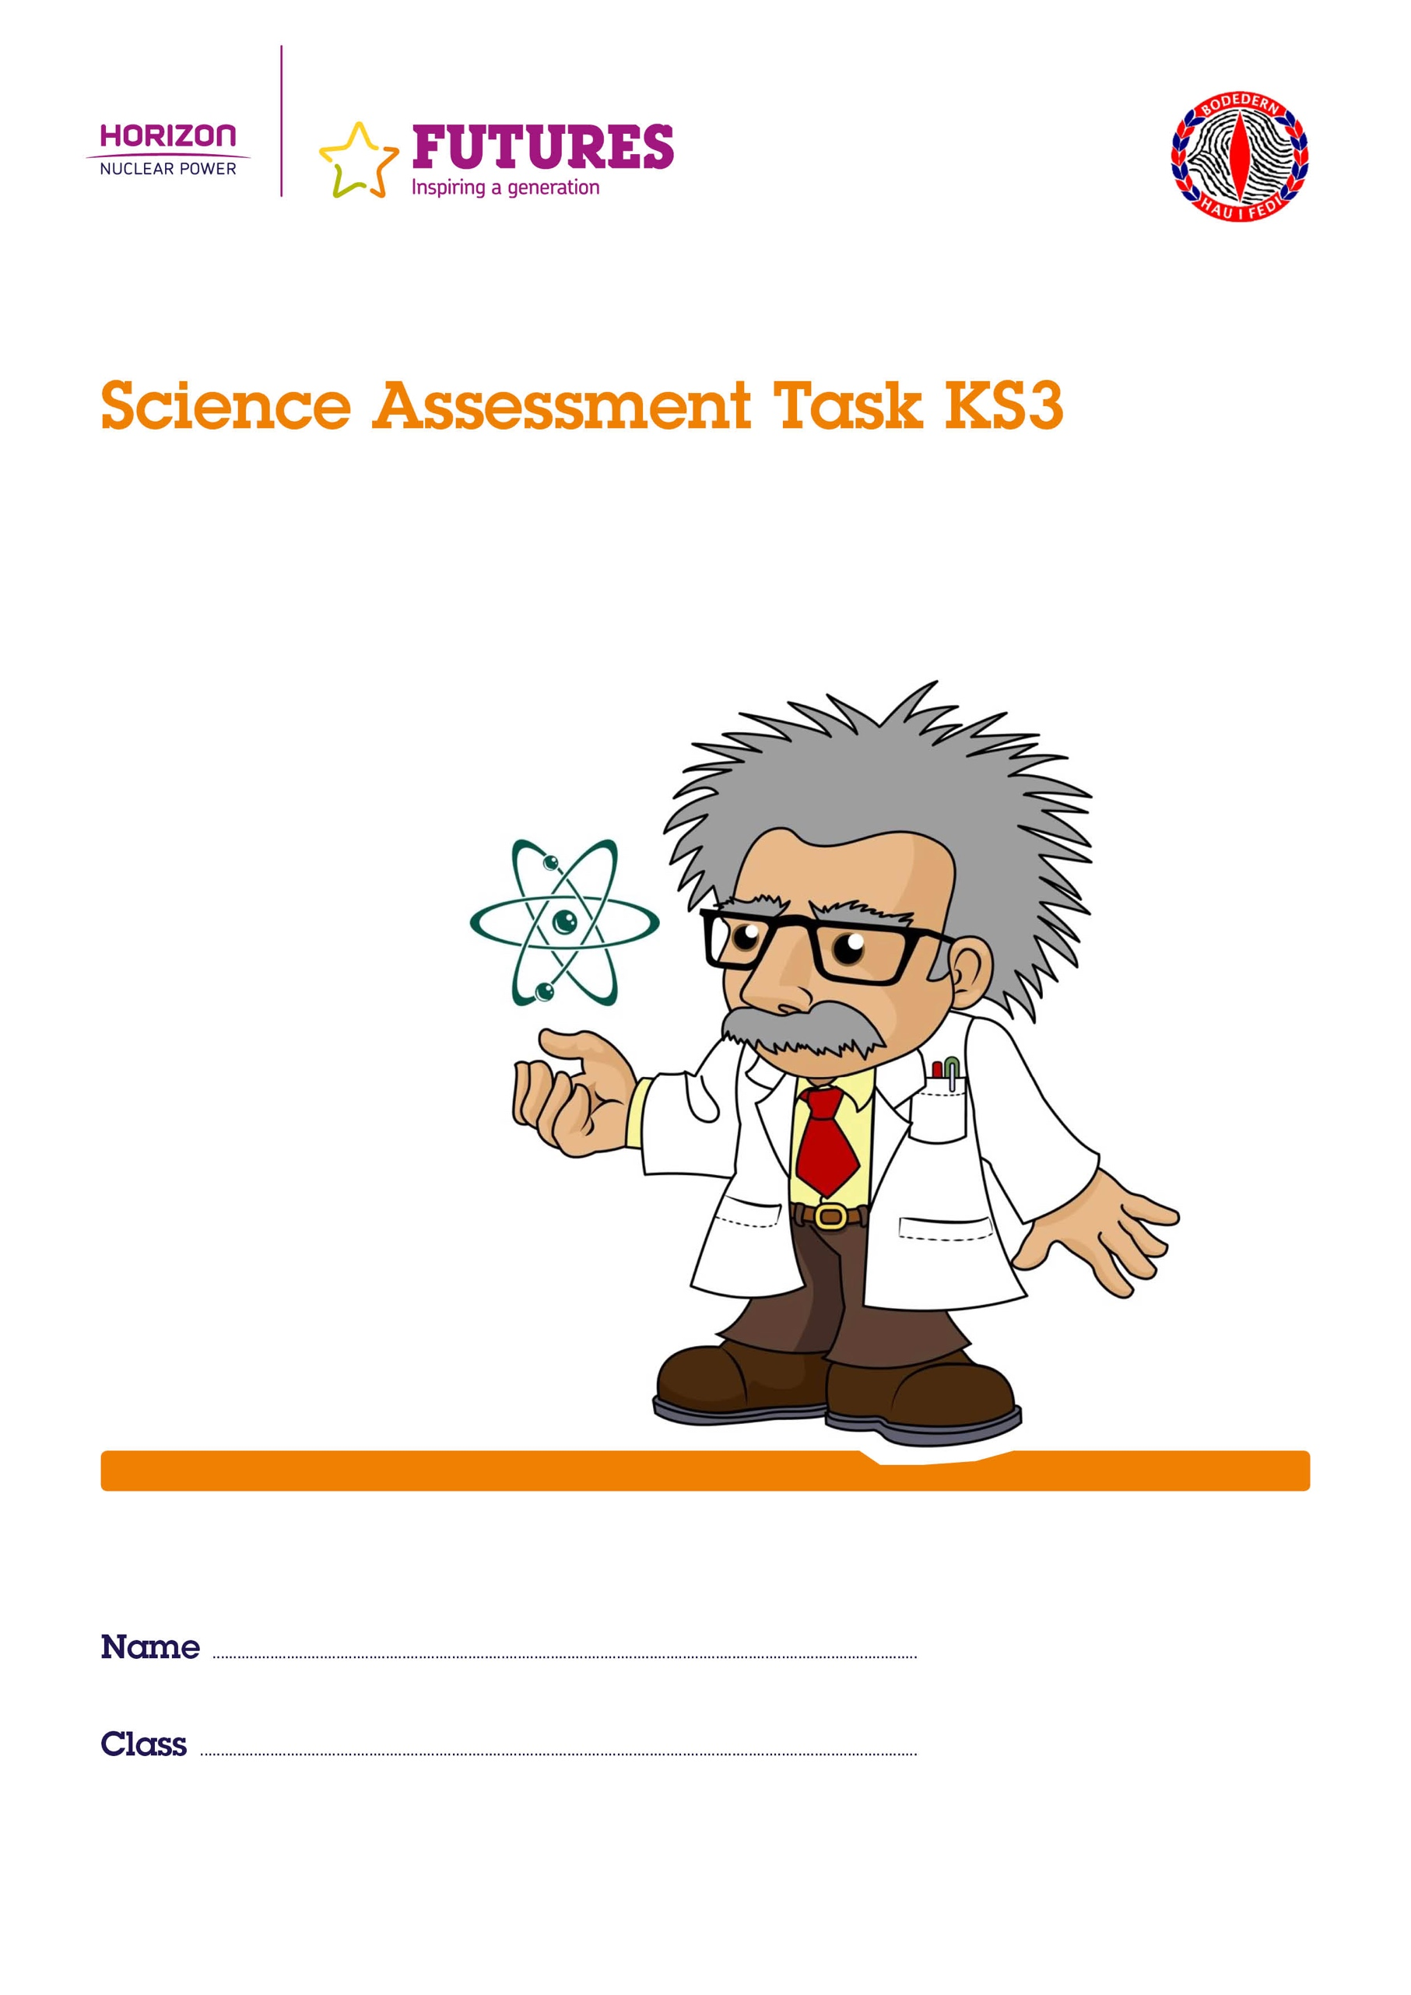

Success Criteria | Tick
I have planned the investigation (Prediction, Fair Test, Risk Assessment and Reliability)
I have made measurements
I have collected data
I have recorded results
I have plotted a graph

I have discovered a trend
I have noted a relationship between the variables
I have given a scientific explanation of the relationship
I have evaluated the experiment by discussing these criteria and ways of improving the measurements

Our Investigation is: ____________________________________
_________________________________________________________

Prediction
_________________________________________________________
_________________________________________________________
_________________________________________________________
_________________________________________________________
_________________________________________________________
_________________________________________________________

Diagram of the Equipment

Fair Test
_________________________________________________________
_________________________________________________________
_________________________________________________________
_________________________________________________________
_________________________________________________________
_________________________________________________________
_________________________________________________________
_________________________________________________________
_________________________________________________________
Method
_________________________________________________________
_________________________________________________________
_________________________________________________________
_________________________________________________________
_________________________________________________________
_________________________________________________________
_________________________________________________________
_________________________________________________________
_________________________________________________________
_________________________________________________________
_________________________________________________________
_________________________________________________________
Results Table

Graph

Stick a Graph here

Analysis
_________________________________________________________
_________________________________________________________
_________________________________________________________
_________________________________________________________
_________________________________________________________
_________________________________________________________
_________________________________________________________
_________________________________________________________
_________________________________________________________
_________________________________________________________
_________________________________________________________
_________________________________________________________
_________________________________________________________
_________________________________________________________
_________________________________________________________
_________________________________________________________
_________________________________________________________
_________________________________________________________
_________________________________________________________
_________________________________________________________
_________________________________________________________
_________________________________________________________
Evaluation
_________________________________________________________
_________________________________________________________
_________________________________________________________
_________________________________________________________
_________________________________________________________
_________________________________________________________
_________________________________________________________
_________________________________________________________
_________________________________________________________
_________________________________________________________
_________________________________________________________
_________________________________________________________
_________________________________________________________
_________________________________________________________
_________________________________________________________
_________________________________________________________
_________________________________________________________
_________________________________________________________
_________________________________________________________
_________________________________________________________
_________________________________________________________
_________________________________________________________
Planning

Me | Prediction | Achieved? |  | Colour
 | Talk about the ideas and make simple predictions using everyday experiences. |  |  | 3
 | Use simple scientific knowledge and understanding to predict results |  |  | 4
 | Make predictions with scientific knowledge and understanding including simple models. |  |  | 5
 | Make predictions using abstract scientific ideas. |  |  | 6
 | Be able to plan qualitative predictions using scientific knowledge and understanding from a variety of sources. |  |  | 7

Me | Method | Achieved? |  | Colour
 | Planning method with assistance |  |  | 3
 | Use scientific knowledge and skills to plan |  |  | 4
 | Plan in a systematic way |  |  | 5
 | Suggest a variety of methods and strategies for the investigation |  |  | 6
 | Justify the methods and strategies they intend to use |  |  | 7

Me | Fair Testing | Achieved? |  | Colour
 | Able to identify with assistance the variables to change and measure and those that need to be kept the same. |  |  | 4
 | Identify key variables and be able to choose between independent and dependent variables and those they would keep the same. |  |  | 5
 | Plan how to control the variables that will need to be kept the same and decide on the range and values of the independent variables. |  |  | 6
 | Identify key variables that possibly cannot be easily controlled explaining the reason why. |  |  | 7
Development

Me | Observation And Measurement | Achieved? |  | Colour
 | Follow a simple method of change if necessary in a safe way and collect observations that can be measured using simple equipment. |  |  | 3
 | Make qualitative observations and use standard equipment to measure using accurate units. |  |  | 4
 | Select measuring equipment that enable a series of detailed measurements to be made. |  |  | 5
 | Make detailed observations and detailed measurements using equipment with detailed divisions. |  |  | 6
 | Observe and measure in a systematic way |  |  | 7

Me | Communicate Findings (Table and graph) | Achieved? |  | Colour
 | Arrange a results table and be able to create a bar chart |  |  | 3
 | Able to create an accurate results table without the Teacher’s help |  |  | 4
 | Able to create a bar chart/ line graph after axes have been given |  |  | 4
 | Able to select a bar chart/line graph that depends on the results table |  |  | 5
 | Able to create a bar chart/line graph without assistance |  |  | 5
 | Able to select scales and the axis for their bar chart/line graph and units consistently (e.g. metre) |  |  | 5
 | Uses correct axes and scales |  |  | 6
 | Uses best fit line, omitting the point that does not fit |  |  | 7

Me | Consider the Findings - Analysis | Achieved? |  | Colour
 | Start considering patterns and trends in discussing the table/graph. |  |  | 3
 | Identify patterns and trends when referring to the graph (e.g. as the height increases) the ...) |  |  | 4
 | Use a line graph to describe the relationship between two variables (continuous) |  |  | 5
 | Start using quantitative definitions |  |  | 6
 | Use some quantitative definitions and make calculations using the correct units. |  |  | 7

Me | Explain Findings - Scientific Reason | Achieved? |  | Colour
 | Provide a simple explanation for differences between things. |  |  | 3
 | Use some scientific knowledge to explain findings |  |  | 4
 | Use scientific ideas and understanding (using models) to explain discoveries. (e.g. The height increases due to ...) |  |  | 5
 | Explain the results using abstract scientific knowledge including models |  |  | 6
 | State whether the relationship / pattern between the variables agrees with the prediction. |  |  | 6
 | Apply abstract ideas and make links between processes or systems |  |  | 7

Reflection

Me | Review outcomes and success criteria (Evaluation) | Achieved? |  | Colour
 | Note what worked and didn’t work and start considering how the method could be improved |  |  | 3
 | Decide whether the method was successful and how to improve |  |  | 4
 | Start to evaluate success criteria fully reflecting successful results. |  |  | 5
 | Evaluation of success criteria fully reflecting successful results. |  |  | 6
 | Improve success criteria for the future following their experiences |  |  | 7

Teacher comments

Attainment

Teacher’s Statement
On the whole, your work for the skill:

PLANNING is level _______

DEVELOPMENT is level _______

REFLECTION is level _______

on the attainment ladder.

Signature ........................................................................................... Date ___/___/___

Pupil's statement
In order to improve in the next task, I have to try to do the following:

........................................................................................................................................................................................................................................................................................................................................................................................................................................................................................................................................................................................................................

Signature ........................................................................................... Date ___/___/___

